**SQL Coding Assessment**

**Q1) Execute OVER and PARTITION BY Clause in SQL Queries, creating subtotals &Total Aggregations using SQL Queries.**

**Partition By(): is mostly** used with window functions to divide the result set into partitions to which the window function is applied separately. This clause is commonly to perform calculations or aggregations within specific groups of rows.

**Over():** The Over function defines the window of rows to which the window function is applied.

Some window functions present in SQL are: **avg(),sum(),min(),max(),count(),rank() etc.**

**Here I have used SUM and MAX for example purposes**

* **Executing Over and Partition by using Sum()**

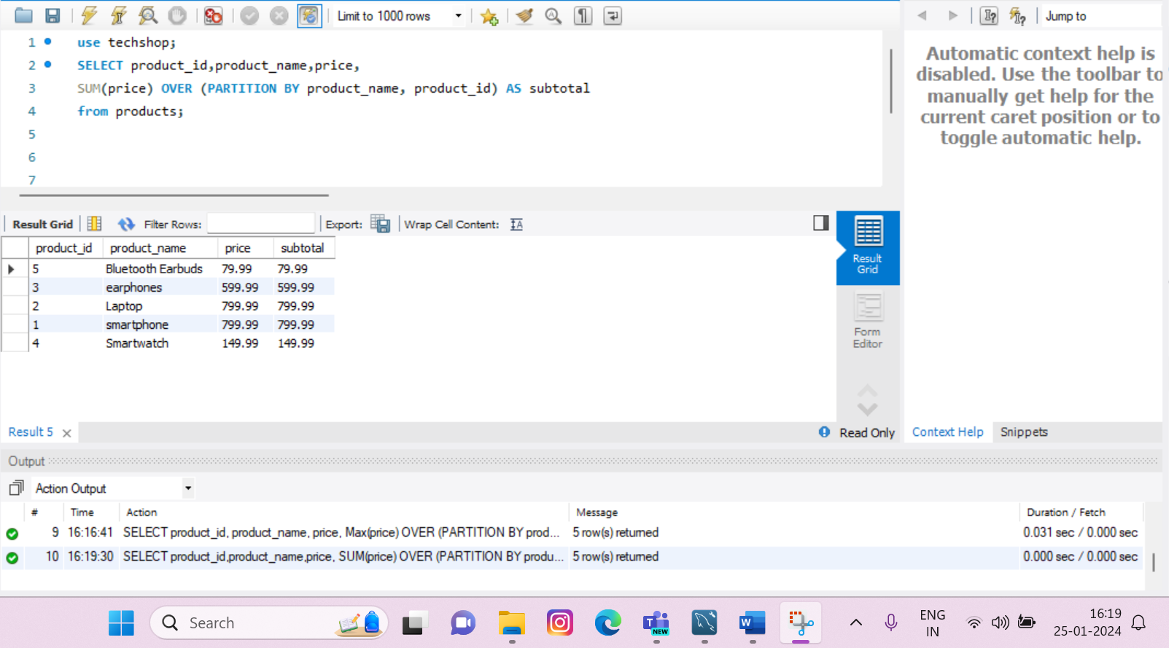

* **Executing Over and Partition by using Max() and Order BY**

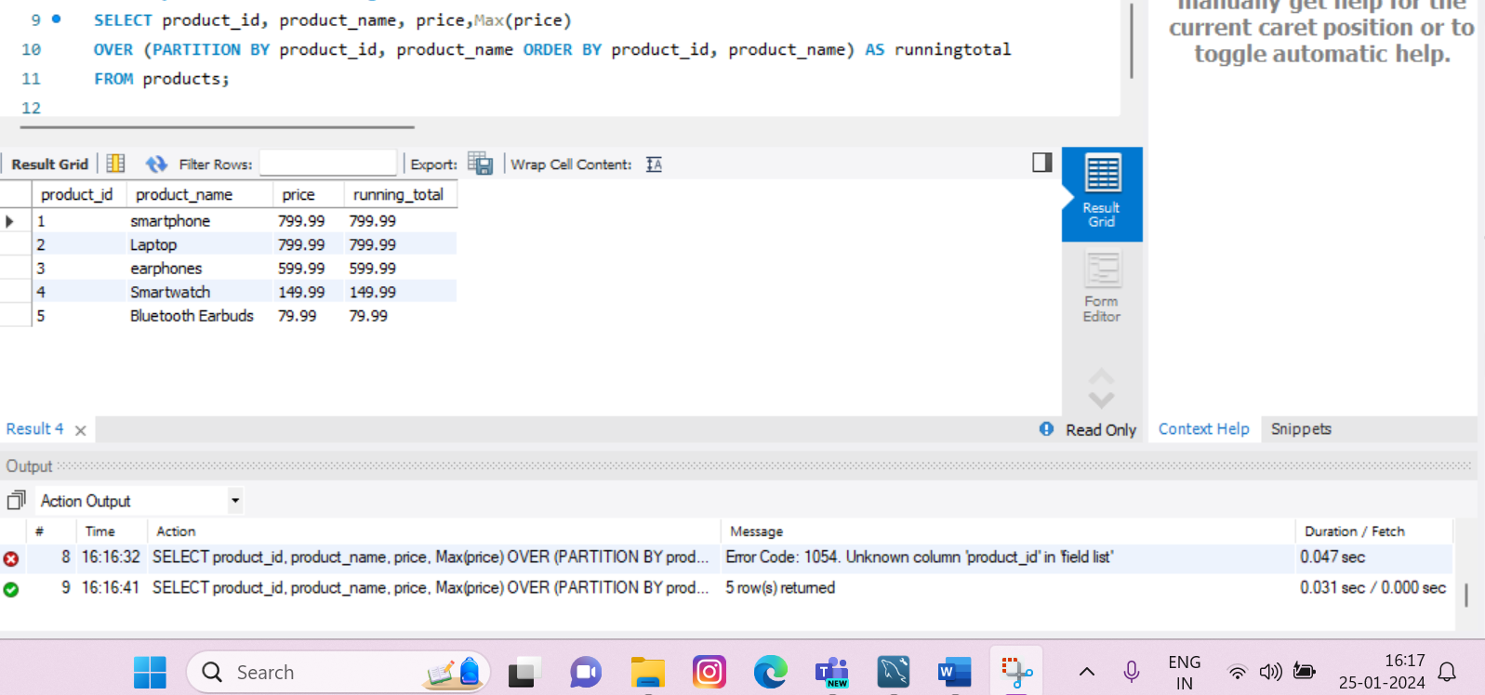

* **Executing Over and Partition by using Min()**

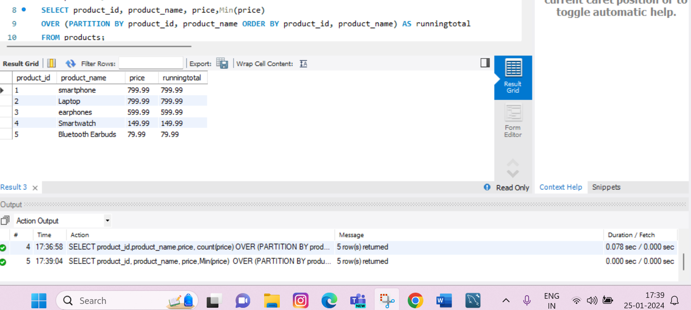

* **Executing Over and Partition by using Avg ()**

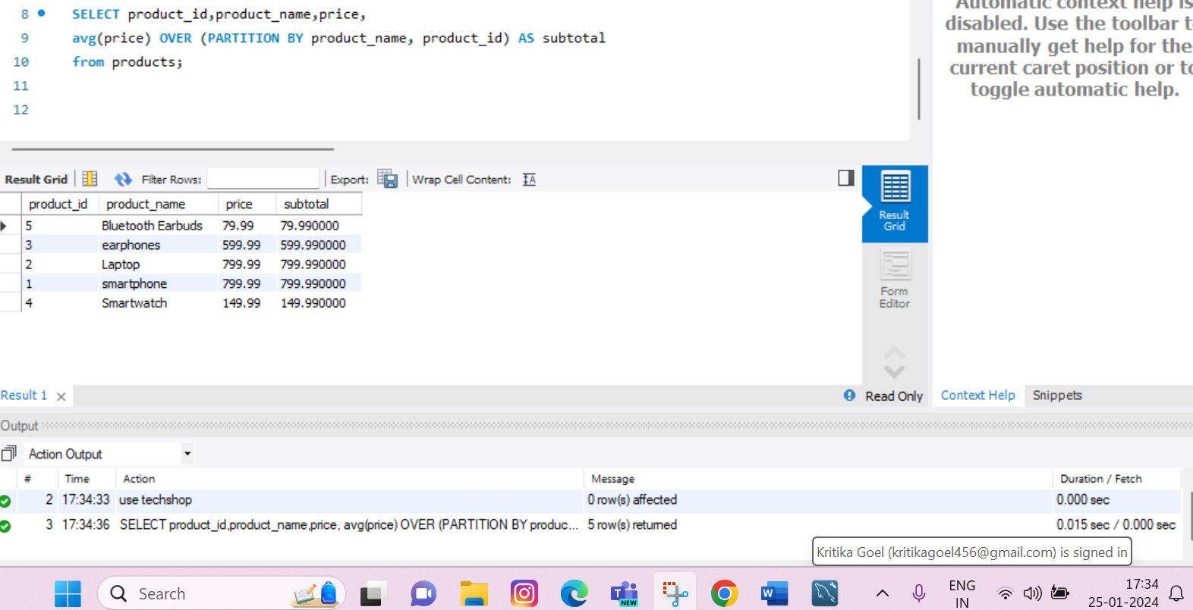

* **Executing Over and Partition by using count()**

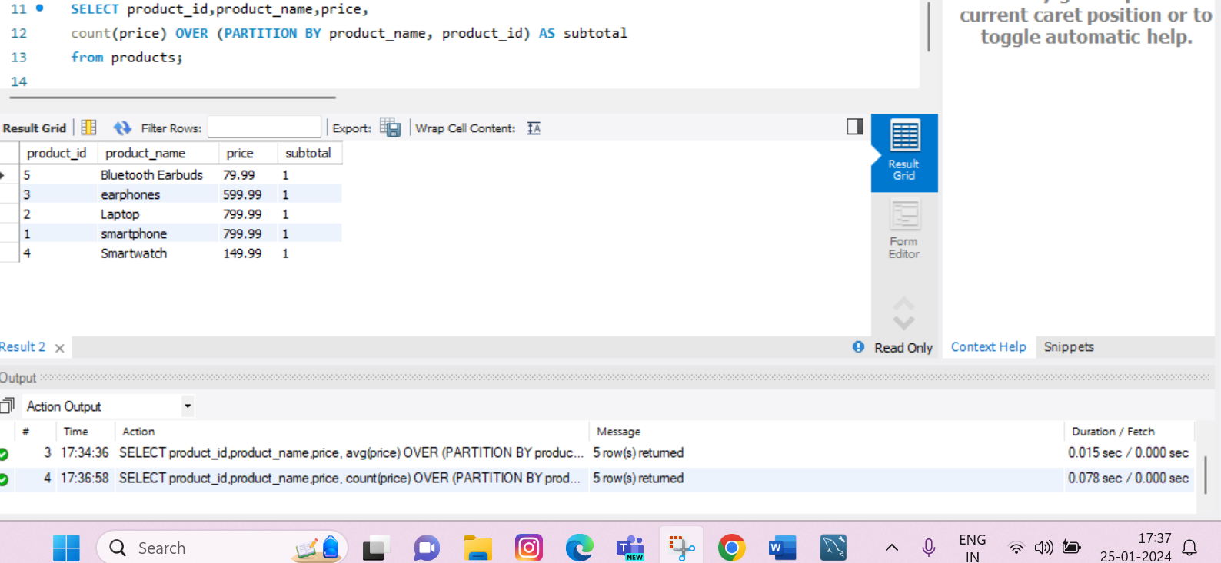

**Q2) Execute all the join with examples.**

* **Natural Join: It automatically matches and combines rows from two tables based on columns with the same name and data type.**

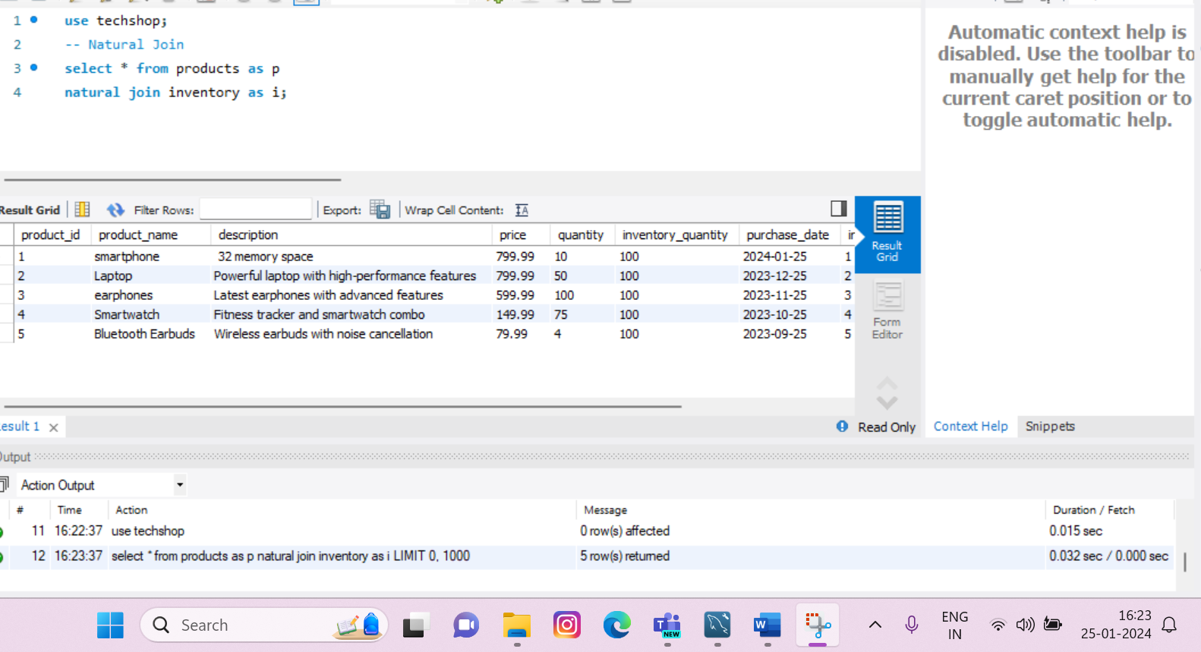

* **Self join : It Joins a table with itself.**

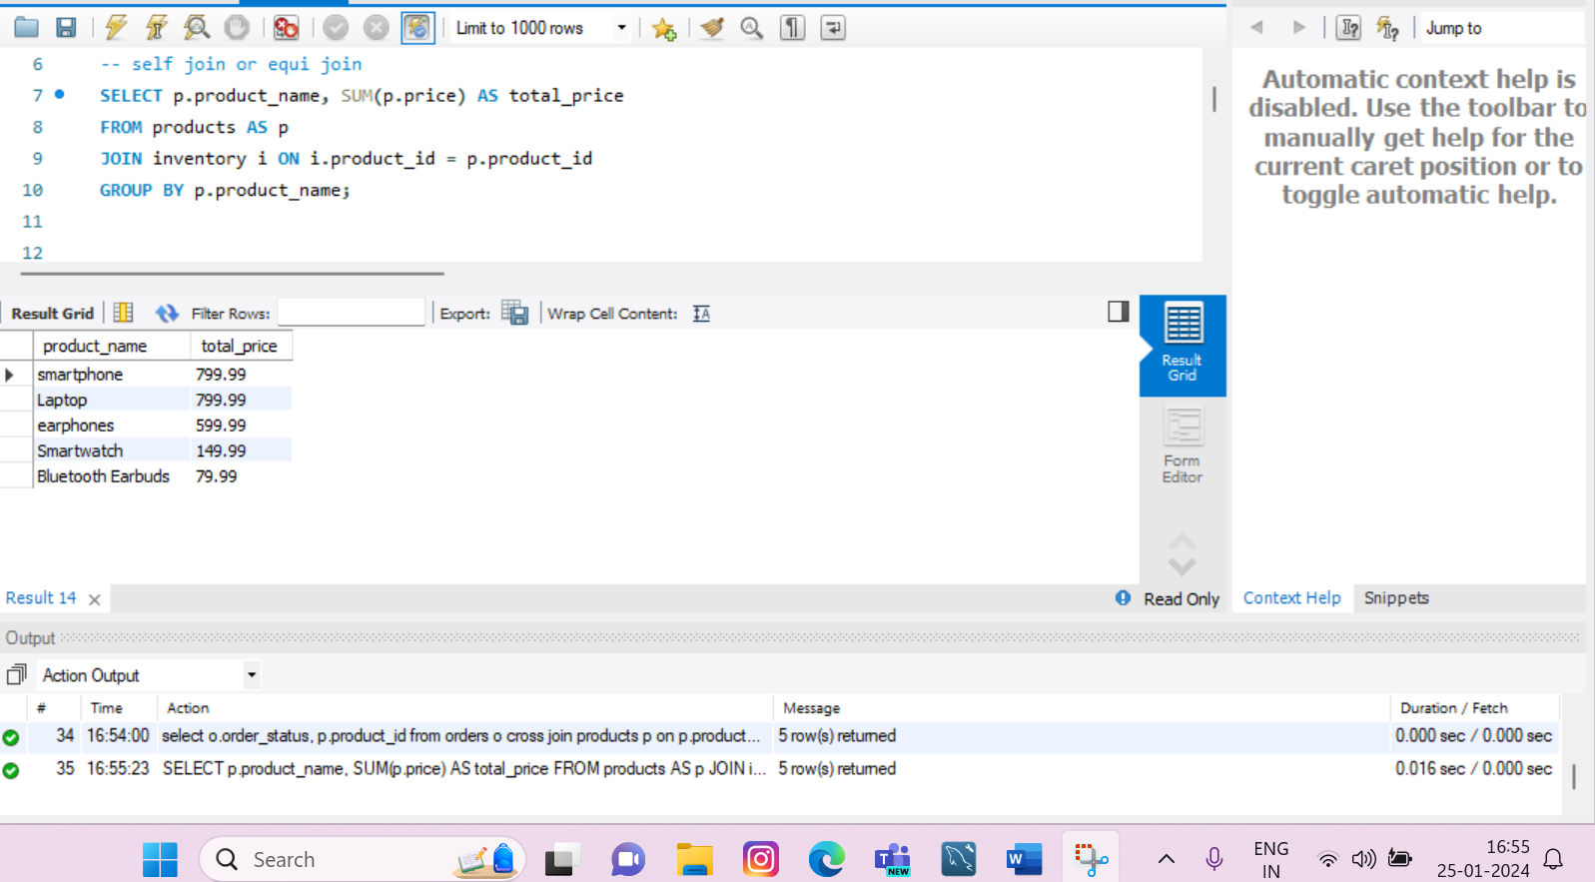

* **Left Join: It returns all the rows from the left tables and the matching rows from the right table**

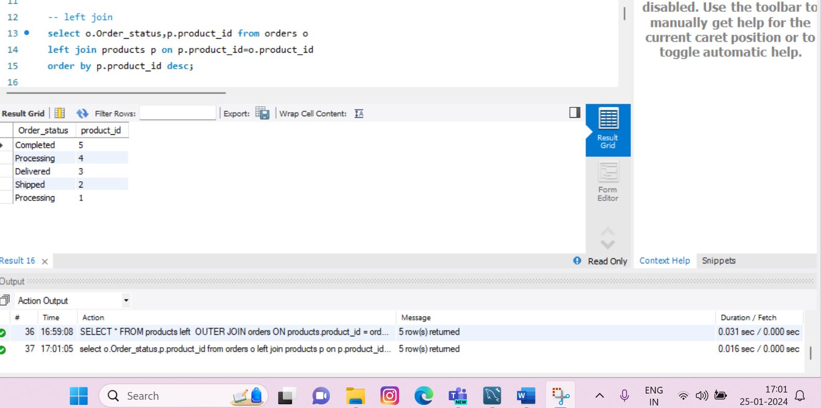

* **Right join: It returns all the rows from the right table and the matching rows from the left table**

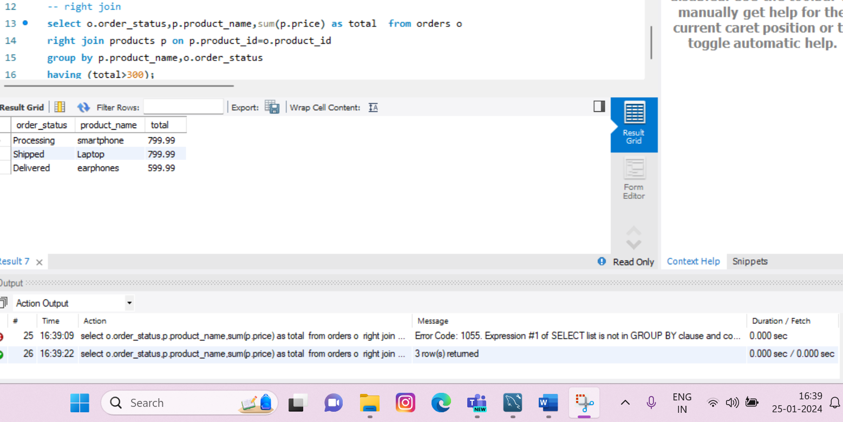

* **Inner Join: Returns the rows where there is a match in both tables based on a condition**

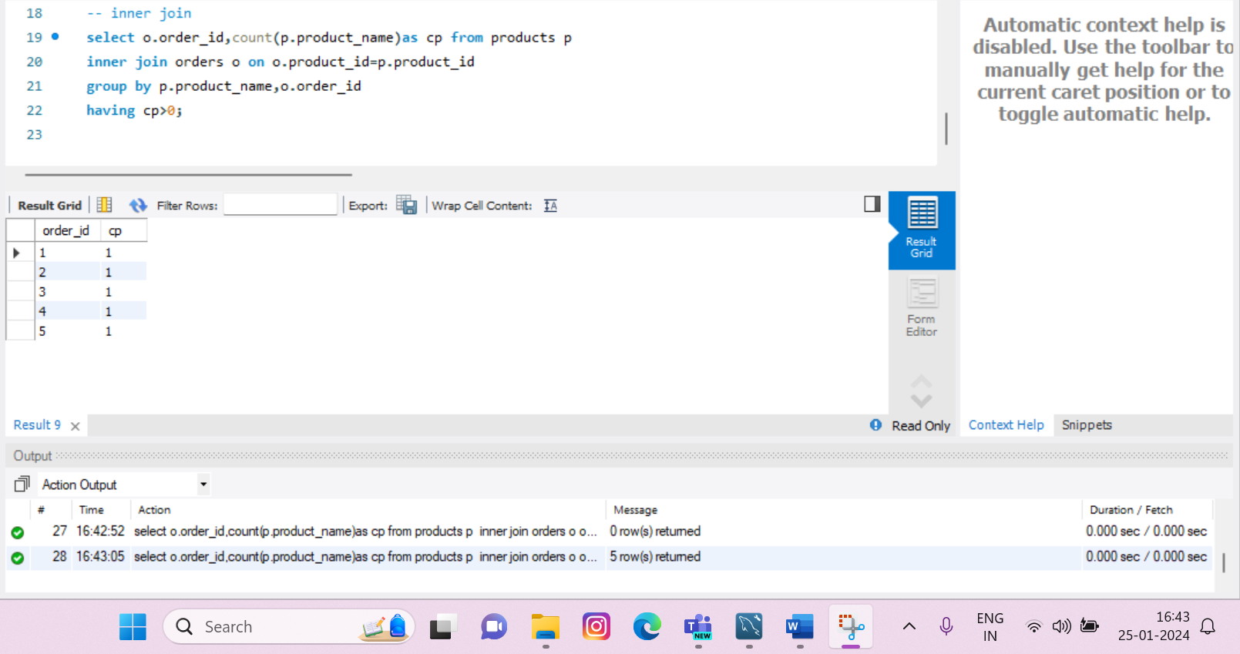

* **Non-Equi Join: A non-Equi join is a type of join that involves comparing columns using operators such as >,<,>=,<= etc.**

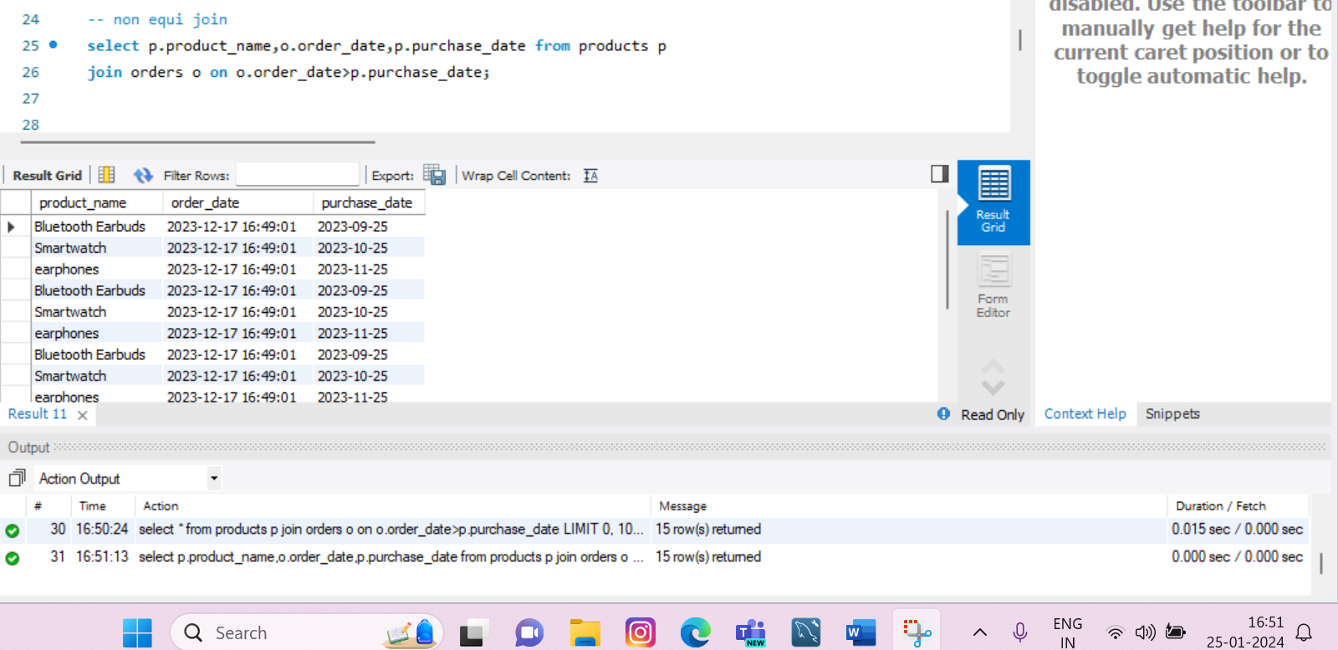

* **Cross join: It returns the Cartesian product of the two tables.**

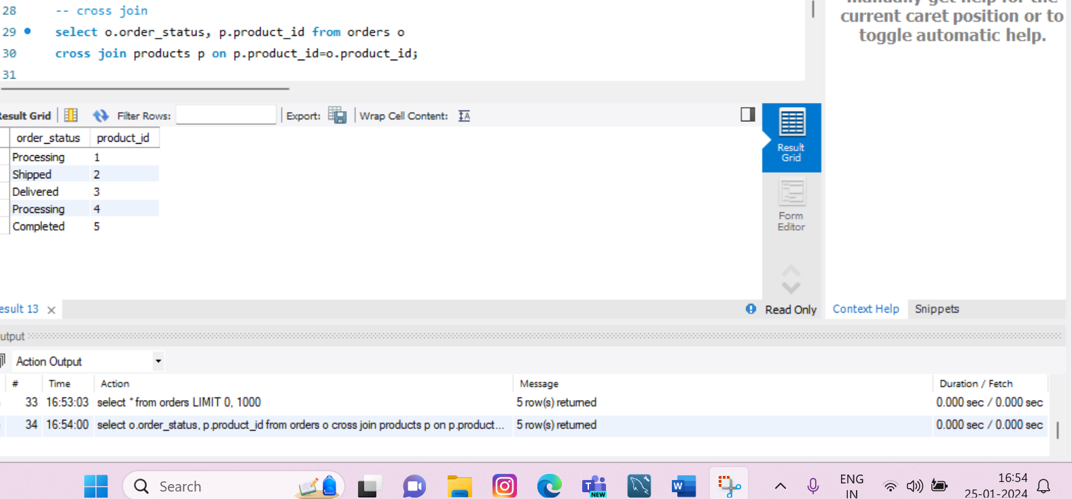

* **Full outer Join: It returns all the values from both tables and null if there is no match, for columns from the table without a match.**

